ALTA MONS GUEST ACCOMODATIONS: INFORMATION AND FEES
www.altamons.org, office@altamons.org, call 540-268-2409, or fax 540-268-9503
Visa, MasterCard, American Express and Discover Accepted

Year Round Rates: Monday through Wednesday
Value Season: November 1st through March 31st
Prime Season: April 1st through October 31st
Overnight Accommodations: Check in time is 4:00 PM. Check out time is 1:00 PM. Day Use Facilities: 9:00 AM to 5:00 PM.
Linens can be provided for an additional $10.00/person
Groups with the majority of participants under the age of 18 will pay the year round rate

Overnight Accommodations
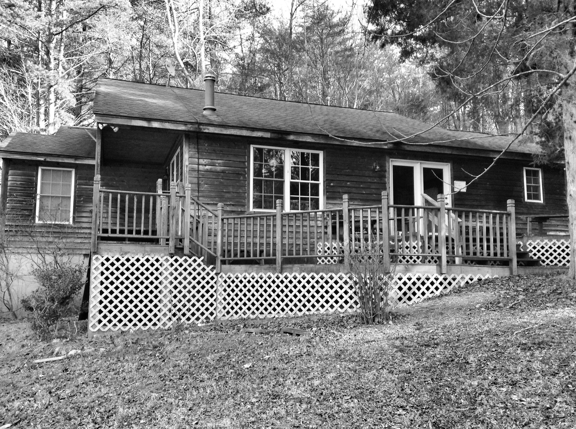  Mountain View | $15.00/person  $120.00/night Minimum  Mon – Wed $160.00/night  Value Rate: $160.00/night  $190.00/night Maximum  Day Use: $125.00/day  Deposit:$100.00 | This facility is perfect for small group retreats. 4 bedrooms, 2 full bathrooms. One bedroom contains a queen size bed with linens. 7 bunk beds divided between 3 rooms. The house also has a fully equipped kitchen with eating area, common meeting area, and access to a porch. Includes a charcoal grill. Heated and air conditioned.  16 person max
Carter Cottage  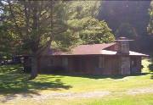 | $15.00/person  $120.00/night Minimum  Mon – Wed $160.00/night  Value Rate: $160.00/night  $190.00/night Maximum  Day Use: $125.00/day  Deposit:$100.00 | This facility is perfect for small group retreats. 4 bedrooms, 2 full bathrooms. 6 bunk beds divided between 3 bedrooms. One bedroom contains a double bed with linens. The cottage also has a fully equipped kitchen, dining table and chairs, rocking chairs. Charcoal grill provided. Heated but not air conditioned.  14 person max
Crockett Retreat Center  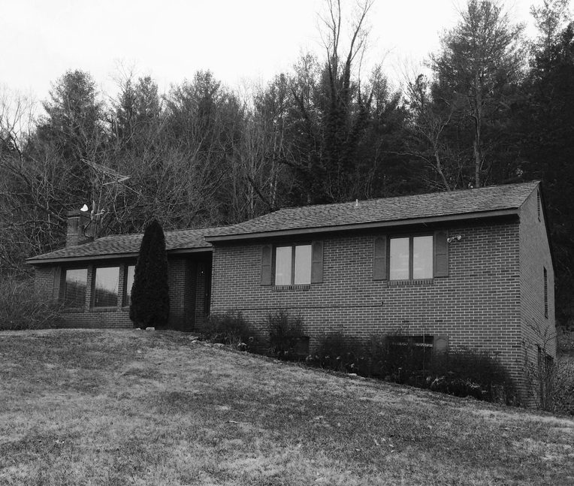 | $15.00/person  $120.00/night Minimum  Mon – Wed $160.00/night  Value Rate: $160.00/night  $190.00/night Maximum  Day Use: $125.00/day  Deposit:$100.00 | This facility is perfect for small group retreats. 3 bedrooms, 2 full baths, 7 bunk beds and 1 cot divided between the 3 bedrooms. The house also has a fully equipped kitchen, meeting space and dining area as well as a deck. Charcoal grill provided. Heated but not air conditioned. Additional meeting space downstairs.  15 person max
Pearman Retreat Center  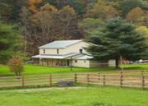 | $20.00/person  $300.00/ night Minimum  Mon – Wed $385.00/night  Value Rate: $385.00/night  $450.00/night Maximum  Day Use: $250.00/day  Deposit:$150.00 | This facility is perfect for small or large group retreats. 11 bunk beds divided between 3 rooms. 2 bedrooms with 2 single beds, fully equipped kitchen, large meeting room, piano, gas fireplace, phone (local calls only), handicap accessible full bathroom on lower floor, 2 other full bathrooms, heated and air conditioned, large charcoal grill, fire pit, volleyball net, tables and chairs, rocking chairs. Covered balcony and porch. (Large field space available for tent overflow at the rate of $2.50/person/night)  26 person max
Burrows Retreat Center  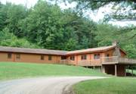 | $75.00/room/night  12 room Minimum  Mon – Wed $65.00/room/night  Value Rate: $65.00/room/night  Day Use:  Upper conference room & Kitchen $ 275.00/day  Both Upper and Lower conference rooms and kitchen: $350.00/day  Deposit: Starting at $240.00 | This facility is perfect for small or large group retreats. 20 rooms have 2 single beds and 3 rooms have 1 bunk bed and 1 single bed. 1 room has 1 single bed and 1 trundle bed. Rooms have individual heat controls and bathrooms are shared by 2 rooms. On the main level a full kitchen, large meeting room with a piano, gas fireplace round tables, padded chairs, lectern, and a TV/DVD/VCR. The lower level contains a meeting room with kitchenette, refrigerator, lectern, tables and chairs. This facility also has a beautiful deck with rocking chairs overlooking the pond, a phone (local calls only), wireless internet, air conditioned meeting rooms & hallways.  52 person max
Prime Season Only Overnight Accommodations

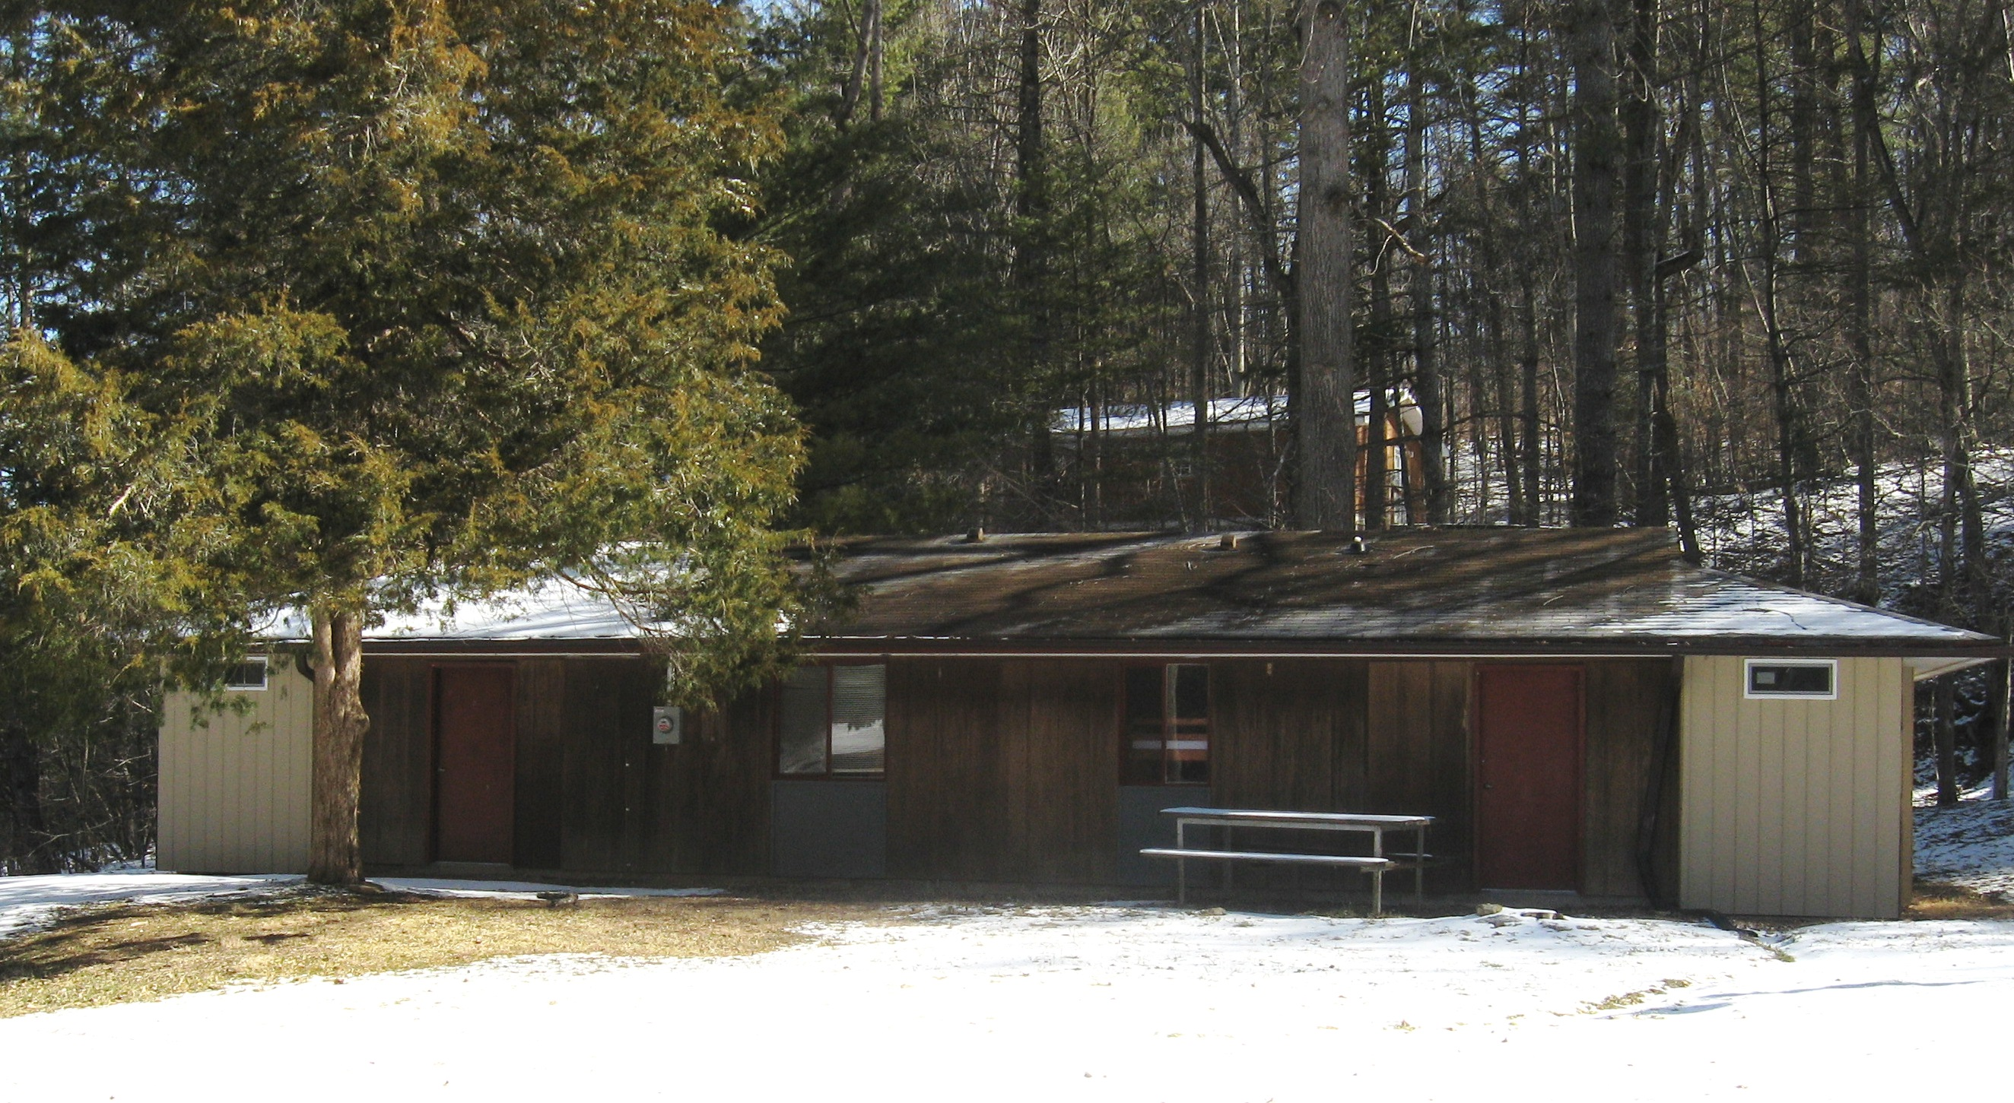  Staff House | $100.00/Night  Deposit: $50.00 | This facility is split into 2 sides: each side has a bathroom with 2 showers, toilets and sinks. The front side has 5 bunks and the back side has 4 bunks. Each side also includes a mini fridge.  18 person max
The Hut  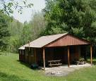 | $50.00/Night  Deposit: $25.00 | Two cabins, each containing 4 bunk-beds adjoining a communal meeting space. Woodstove, porch, grill, large fire pit with cross and altar, field space, porta john and fridge. (Large field space available for tent overflow at the rate of $2.50/person/night)  16 person max
Rustic Cabins  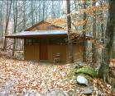 | $50.00/Cabin/Night  Deposit: $25.00 | 9 rustic cabins each containing 4 bunk beds and an additional single bed. Each cabin has at least 1 electrical outlet. The morning watch chapel and communal bathhouse are located nearby.  9 person max per cabin
Hogans  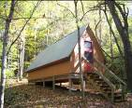 | $50.00/Hogan Site/Night  Deposit: $25.00 | Located in an isolated and wooded area of the property, each site has 2 hogans (A-frame cabins) which share a picnic shelter and fire pit. There are 3 hogan sites. No electricity, no water, no bathhouse! Porta john nearby.  16 person max per hogan site
Adventure Cabin  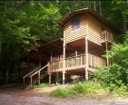 | $50.00/Night  Deposit $25.00 | The adventure cabin is split into 2 sides: each side has 4 bunk beds and is reached by a set of stairs giving the impression of sleeping among the trees. Underneath this is a covered shelter with a large picnic table. Fire pit and porta john nearby.  16 person max

Camping: RV & Tent  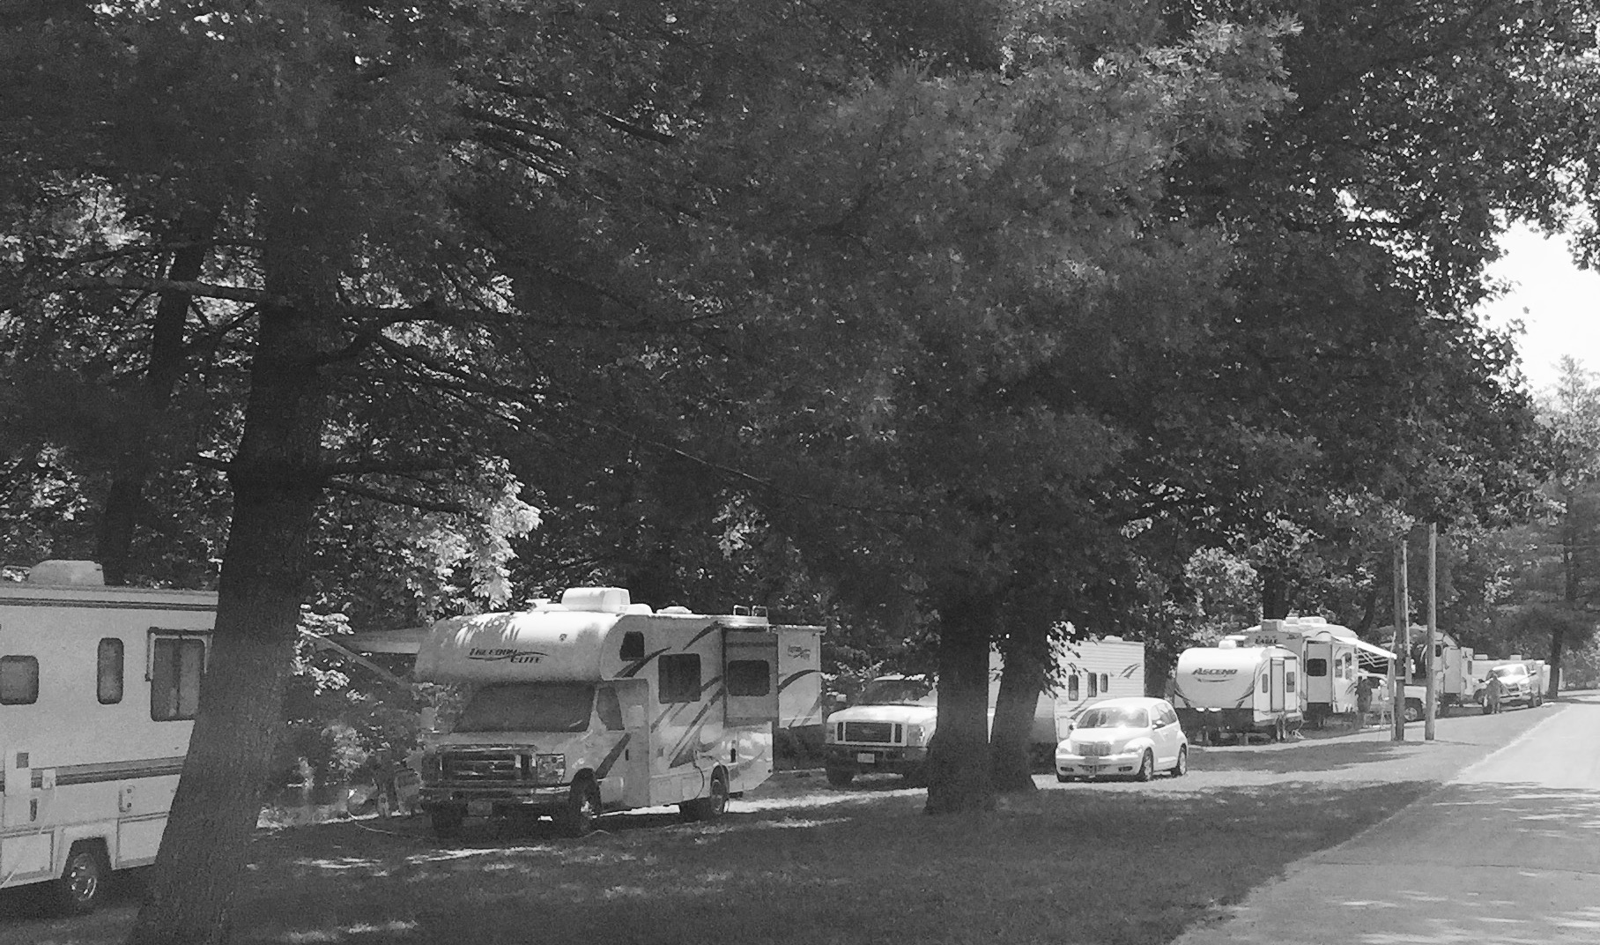 | RV Camping  $25.00/site/night  Deposit: $25.00/site/booking  Tent Camping  $15.00/site/night  Deposit: $15.00/site/booking  Maximum 3 tents per site | There are 2 locations available for RV camping, the Wetlands (24 sites plus 2 pop up sites) and the Riverside (13 sites). The Wetlands has a communal RV shelter and the RV bathhouse. The Riverside has a communal RV shelter, communal fire pit and a central dump station. Each individual site has electric hook-up, 30 amp and 20 amp, water hook-up, picnic table and a fire pit.  There are 7 tent sites. Each tent site comes with a picnic table and fire pit. There is a communal water spigot, porta john, and bathhouse nearby.

ALTA MONS GUEST SERVICES: INFORMATION AND FEES

Shelter I, II & III  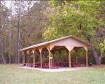 | Shelter I or II $115.00/Day  Shelter III  $175.00/Day  Deposit: $50.00 | Shelter I, located next to the creek, and Shelter II next to the pool, each contain 8 picnic tables, a charcoal grill. These shelters have lighting and electrical outlets and are surrounded by field space.  Shelter III, located near the Wetlands area, contains 16 picnic benches and a large charcoal grill. It has electrical outlets and is surrounded by field space.
The Dining Hall  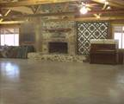  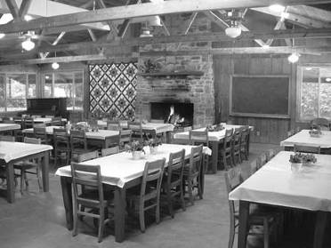 | $300.00/Day  (Both Sides)  One Side Only (Program or Dining): $180.00/Day  Deposit: $100.00 | The Dining Hall consists of 2 large meeting rooms adjoined by a hallway. The “Program Side” is a large open space stocked with folding tables and chairs for multi-purpose use. The “Dining Side” has large wooden tables and chairs. This beautiful wooden dining space has a rural feel with the wooden rafters and quilts hanging on the walls. Each side has a beautiful stone fireplace and chimney for real wood fires and a piano.
FOOD SERVICE
Food Service  Regular Menu | Adults :  Breakfast $9.00/person  Lunch $10.00/person  Dinner $12.00/person  12 and Under  Breakfast $8.00/person  Lunch $9.00/person  Dinner $10.00/person  3 and Under  Breakfast $2.00/person  Lunch $2.00/person  Dinner $2.00/person | Dine in our comfortable and beautiful wooden dining hall with a real wood fire to create a rustic-style atmosphere.  Contact the office for our current menus and to make meal reservations.
Hot Beverages: self-serve | 0-25 people - $25.00  25-50 people- $35.00  50-75 people $45.00 | coffee/creamer/sugar/sweetener/tea bags

ALTA MONS GUEST SERVICES: INFORMATION AND FEES

Programs and Activities
Public Use

Self-guided Hikes | No charge, donations welcome | Park at the office, check out the map at the hiker sign in and enjoy the beauty of 850 acres! Please stay to assigned trails and roads.
Volleyball/Basketball Courts | No charge, donations welcome | Borrow equipment at the Camp Post
Horseshoes | No charge, donations welcome | Equipment kept at horseshoe site
Pond | No charge, donations welcome | Catch and Release Fishing  Barbless hooks only, bait not supplied.

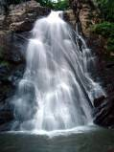
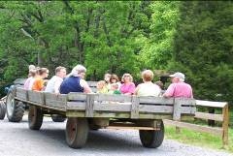
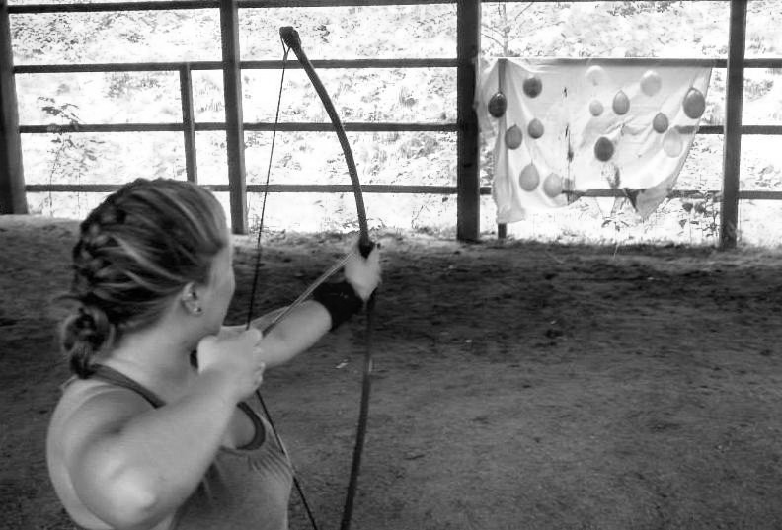
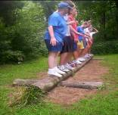

Programs and Activities
Group Use
Wagon Rides | $55.00/Wagon  Deposit: $20.00 | Enjoy a scenic ride around the camp old-fashioned style in one of our wagons. The ride takes approximately 1 hour and can accommodate up to 30 people. Take time to soak up the scenery and tell camp tales!
Pool | $115.00/25 people/2 hours  $185.00/50 people/2 hours  $255.00/75 people/2 hours  Deposit: $50.00 per lifeguard | Pool times must be contracted  Note: Regulations require 1 lifeguard per 25 people; Max 75 people in the pool at a time.
Low Ropes | $180.00/3 hours/ group  Deposit: $50.00 per facilitator | Facilitators will take groups of people through the course to work on trust, communication, and team work! Your low ropes experience will be specialized for what your group is looking for!  Note: A “group” is defined as 20 people or less
High Ropes | $100/Element/ Hour  Deposit: $50 per facilitator | Choose from 9 different high adventure courses including a Two Line Bridge, Dual Belay Catwalk, Lily Pads, Swing Shot, Flying Squirrel, Pamper Pole, and a tri-challenge element which includes a Multi-vine traverse, Catwalk, and a Zipline.
Other activities such as canoeing on the pond, nature lessons, archery, fire building lessons, etc. available by special request! Simply call our office at 540-268-2409.

